Explainable AI-Driven Multimodal Analytics for Sustainable Smart City Decision Intelligence
Sharmila Pathi^{A}, Vishnu Priya Kodali^{A}, Ivaturi Vennela^{A}, Lakshman Angara^{A}
^{A}Department Of Computer Science and Engineering. Koneru Lakshmaiah Education Foundation, Bowrampet, Hyderabad- 500043, Telangana, India.
Data Analytics and Visualization — Project Research Paper

ABSTRACT
1. INTRODUCTION
With rapid urbanization, managing urban sustainability has become complicated. In this study, we propose an explainable data analytic solution to enable sustainable smart city decision intelligence. We analyze the air quality, past weather and energy consumption data sets to develop an integrated and explainable data analytics solution. We preprocess the data, conduct exploratory data analysis, correlation analysis followed by feature engineering and feature selection steps. We compare various machine learning models to find the best model to predict the response variable using metrics like Mean Absolute Error, Mean Squared Error, Root Mean Squared Error, R2 score, Mean Absolute Percentage Error, Median Absolute Error, Explained Variance Score, Max Error, Adjusted R2, Normalized Root Mean Squared Error. We develop a novel Out-of-Fold Linear- Catboost- Gradient Boosting Ensemble model (LCG-Stack) with Linear Regression as the Meta Learner. Using SHAP we gain insight into the model prediction and identify the influential features. We also perform cross domain analysis to understand the relationship between various variables. The proposed solution offers predictive, explainable and interactive analytics to gain insight into the data.
  - Background
Urbanization has increased rapidly and urban systems have become more complex. This has increased the demand for data driven solutions to aid sustainable smart city applications. Cities produce diverse data from various sources such as air quality, weather and energy consumption. By analyzing this data we can gain insight into the patterns observed in the environment and understand how resources are being consumed. As a result, these data can be used to help make decisions to promote sustainability. Machine Learning has been widely used to make predictions from environmental and energy data to extract useful patterns [1][4][7][17][18].
This has encouraged the use of ensemble, hybrid and explainable AI models. Previous work has looked to use various machine learning and ensemble methods to make predictions about air quality and energy [3][5][6][16-22]. SHAP has been used as an explainable AI technique to understand the predictions made and identify influential factors [1][2][8][15][26][28][30]. However, these studies are focused on making predictions in one area. There is little work looking to combine the data from various sources such as air quality, weather and energy to create a solution that compares various models and provides explainable predictions.
  - Problem Statement
Many studies look to make predictions using data from one area such as air quality, weather or energy consumption. This can result in models being developed that give useful information but are not able to provide an overview of the situation in the environment and resources. Additionally, if the models developed are very predictive they can be hard to explain.
  - Research Gap
Studies have looked to use machine learning to make predictions in one area of the smart city such as air quality [1-3][5][6]. Energy consumption [4][8][9] and urban environments [7]. Recent work has looked to use ensemble and hybrid models to aid predictions [16-22]. Studies have also looked to use explainable AI to understand the predictions made [1][2][8][15][26][28][30]. However, these studies focus on making predictions in one area. There is little work looking to use data from various areas to make predictions.
Often the focus of the studies is on the accuracy of the predictions and do not look to combine the models, cross domain predictions and explainable AI together. An integrated approach is needed that compares multiple models, combines them using out of fold stacking, provides explainable predictions using SHAP and provides cross domain insights. This study looks to address these issues by creating an explainable cross domain analytics solution.
  - Research Objectives
- Provide an integrated analytics solution to understand air quality, weather and energy consumption in a sustainable smart city

- Compare various regression models from machine learning to predict the response variables.

- Validate the accuracy of the models developed by using testing data.

- Measure the models accuracy using Mean Absolute Error, Mean Squared Error, Root Mean Squared Error and R2 Score. Provide insights into the features using SHAP.

- Provide an interactive dashboard offering insights into the analytics, predictions and explanations.
  - Research Questions
- What insightful patterns can be identified from the air quality, weather and energy data?
- What data issues exist in the three heterogeneous data sets and how can these be resolved?
- Which features provide the most relevant information to predict air quality, weather and energy?
- How do the features affect the predictive ability of the variables?
- How do the regression models perform?
- Which models provide the most accurate predictions?
- Does the Out-of-Fold Linear- Catboost- Gradient Boosting Ensemble model (LCG-Stack) provide accurate predictions?
- How effective is the out of fold stacking method in combining the predictions from Linear Regression, Catboost and Gradient Boosting?
- Which features are most influential in the models?
- How can SHAP be used to explain the predictions?
  - Contributions
- Provide an integrated analytics solution to understand air quality, weather and energy.
- Compare various regression models from machine learning using the same metrics.
- Provide an integrated hybrid model using Linear Regression, CatBoost and Gradient Boosting with out of fold stacking and Linear Regression as the meta learner to provide robust predictions.
- Provide an explainable AI solution using SHAP to understand the predictions and quantify the features.
- Perform cross domain analytics and scenario analysis to understand the relationship between the environmental and energy variables.
- Provide an interactive dashboard to provide insights into the predictions, explanations, cross domain evidence, scenario identification and suggested actions.
- Provide an end to end solution that can be reproduced with preprocessing, exploratory analysis, feature engineering, feature selection, model development, evaluation, explainable AI, cross domain analysis and visualisation.
  - Organization of the Paper
Section 2 discusses the related work surrounding smart city analytics, machine learning and explainable AI. Section 3 introduces the methodology of the proposed solution with the data sets, preprocessing, exploratory analysis, feature engineering, feature selection, baseline models, the proposed hybrid model and SHAP. Section 4 discusses the experiment set up. Section 5 provides the experiment results, comparing various models, provide explanation using SHAP and performing cross domain analytics. Section 6 discusses the key findings, cross domain relationships and scenarios. Section 7 discusses the limitations of the study. Section 8 concludes the paper and provides future work.
2. RELATED WORK
2.1 Existing Approaches
Traditionally air quality, energy management and urban environments have been managed using statistical analysis, monitoring and domain specific prediction methods. However, recent studies focus on using machine learning to make predictions from the air quality [1-9][17][18], energy consumption [4][8][9][18-21], weather and other urban environment data. Air quality studies often focus on looking to predict the air quality index and pollution using pollutant and weather variables [1-3][5][6]. Energy studies use machine learning and deep learning models to predict building and electrical consumption [4][8][9][18-21]. Ensemble and hybrid models have been looked into to combine several models to improve the predictions [16-22]. Explainable AI techniques such as SHAP and LIME have been used to understand the features [1][2][8][15][26][28][30]. However, these methods are focused on making predictions in one area and there is little work looking to combine the data from various areas. This indicates an integrated solution would be beneficial to combine the predictive modelling, ensemble, explainable AI and cross domain analytics.
2.2 Machine Learning / Computational Approaches
The proposed solution uses a machine learning pipeline containing preprocessing, exploratory analysis, feature engineering, feature selection, model development, evaluation and explainable AI. Three heterogeneous data sets have been used to represent three areas of the smart city, air quality, weather and energy consumption. These have been preprocessed to clean the data, handle any missing data and duplicates. Categorical variables have been encoded and features have been created for modelling. Feature engineering has been carried out to create relevant variables and feature selection has been performed to identify the most informative variables.
Various models have been compared to develop the best model to predict the response variables. Baseline models such as Linear Regression, Decision Tree, Random Forest have been used along with other models to compare. This provided insights into the best models to use within the ensemble solution. The final model developed used an Out-of-Fold Linear- Catboost- Gradient Boosting Ensemble model (LCG-Stack) with Linear Regression, Catboost and Gradient Boosting as the base learners and Linear Regression as the meta learner. The out of fold predictions have been used to train the meta learner and avoid leaking information.
The models have been evaluated using regression metrics such as Root Mean Squared Error and R2. Where applicable the models have been trained using 5 fold cross validation with shuffling and fixed random state. The models have also been analysed using SHAP to identify the features contributing to the prediction. The solution has been developed in Python using machine learning and data analysis libraries. The entire solution has been organised and implemented in the project implementation environment.
2.3 Advanced / Alternative Approaches
Various alternative and advanced methods have been considered to provide a meaningful comparison. Baseline models such as Linear Regression, Decision Tree and Random Forest have been used to provide baseline predictions. Other models and ensembles have been compared to see if more complex models provide consistent improvements.
Advanced methods have been reported in previous studies. These include Deep Learning and hybrid models such as CNN-LSTM, LSTM, Random Forest-XGBoost and other ensembles [2][3][16-22]. These show the potential of combining different learning methods. However, these methods often require more computation, tuning and are more complex. This study focuses on using a practical approach with stacking to combine the models.
The final solution proposed was using an ensemble model called LinCatGB-Stack combining Linear Regression, Catboost and Gradient Boosting with out of fold stacking and Linear Regression as the meta learner. SHAP has been used to provide the explainable AI component. Rather than developing a new machine learning algorithm, this study looks to see how the selected ensemble methods, explainable AI and cross domain analytics can be combined into an integrated solution for smart cities. Comparing the baseline and candidate models shows evidence to select the chosen design. Cross domain analysis and the visualisation in the dashboard provides additional insight beyond predictions.
2.4 Explainability / Interpretability (or another relevant sub-theme)
With the increased use of complex machine learning models there is a need for explainable predictions. Recent studies have used explainable AI techniques such as SHAP to identify what factors influence the air quality predictions [1][2]. Explainable AI has been used in energy consumption prediction for sustainable cities to identify the influential factors [8]. These studies show that using explainable AI can increase the transparency and interpretability of machine learning models. However, the majority of studies focus on one prediction area such as air quality, energy or urban environment. An integrated solution would be beneficial to use SHAP to explain the predictions across multiple areas of the smart city.
2.5 Critical Comparison

# | Study / Publication | Key Contribution | Limitation
1 | Birinci et al., Stochastic Environmental Research and Risk Assessment, 2026 [1] | Developed an interpretable machine-learning framework for predicting PM10, PM2.5, and O3 using air-quality and meteorological data with SHAP-based explanations. | Primarily focuses on air-quality prediction and does not provide an integrated analysis across multiple smart-city sustainability domains.
2 | Mohapatra et al., Discover Applied Sciences, 2025 [2] | Developed a CNN-LSTM model for AQI forecasting and incorporated SHAP, LIME, and PDP for model interpretation. | Focuses mainly on AQI forecasting using a comparatively complex deep-learning approach rather than a broader multi-domain smart-city analytics framework.
3 | Jalali et al., Discover Atmosphere, 2025 [3] | Applied AI-based methods for air-quality forecasting and classification using environmental and meteorological information with explainability techniques. | Mainly addresses air-quality and public-health applications rather than integrating environmental and energy-related analytics within a common smart-city framework.
4 | Hussien et al., Discover Internet of Things, 2025 [4] | Compared machine-learning approaches for long-term building energy-consumption prediction. | Focuses primarily on energy-consumption prediction without integrating air-quality and weather analytics into a unified analytical framework.
5 | Özüpak et al., Water, Air, & Soil Pollution, 2025 [5] | Compared multiple machine-learning and ensemble strategies for improving air-quality forecasting. | Concentrates on air-quality prediction and does not extend the analysis to broader cross-domain smart-city sustainability and decision-support applications.

Table 1. [Critical Comparison]
2.6 Research Gap (Summary)
Studies have used machine learning and explainable AI to make predictions in one area of the smart city such as air quality [1-3][5][6], energy consumption [4][8][9] and urban environments [7]. Recent studies have highlighted the increased use of machine learning, ensemble and explainable AI to make predictions on environmental and energy data [10][16-22]. However, there is little work looking to combine air quality, past weather and energy consumption data to provide an integrated solution with comparisons of multiple machine learning models and SHAP explanations/visualisations. This study looks to address this by providing an integrated, explainable and cross domain analytics solution for sustainable smart city applications.
3. PROPOSED METHODOLOGY
3.1 Overall Framework
The proposed solution provides an end to end analytics solution for sustainable smart city decision intelligence. The framework takes data from various areas of the urban environment and combines them. The framework considers air quality, past weather and energy consumption as complementary data sources. Data has been preprocessed, exploratory analysis performed, feature engineering and feature selection carried out. The data sets have been cleaned to deal with missing values, inconsistent data, duplicates and unsuitable variables. Then the data has been analysed to identify patterns and relationships between environmental and energy variables. Multiple models from machine learning have been developed to predict the response variables. The models have been evaluated using the appropriate metrics. A hybrid model has been developed using an out of fold stacking method combining Linear Regression, Catboost and Gradient Boosting with Linear Regression as the meta learner. SHAP has been used to provide explanations to identify the most influential features. Cross domain and scenario analysis has been performed to provide further insights. The results have been put into a dashboard to provide interactive insights into the predictions, explanations, findings and recommendations. A visualisation of the workflow can be seen in Figure 1.
Explainable Data Analytics for Sustainable Smart City Applications
1 Data Sources
Three Heterogeneous
Smart-City Domains
Air Quality
• 500 records
• Pollution Score (target)
Weather
• 96,429 records
• Temperature (°C) (target)
Energy
• 1,000 records
• Energy Consumption (target)
Three Smart-City Domains
2 Data Preparation
Data Preparation
Data Cleaning:
• Missing values
• Duplicates
• Fix types / inconsistencies
Dataset Validation
Train / Test Split
Exploratory Data Analysis
Univariate| Bivariate| Multivariate Correlation
EDA Visualizations
3 Feature Engineering & Selection
Feature Engineering
Air Quality: Pollutant Ratios
Weather: Temporal & Temp/Wind Features

Energy: Time & HVAC/Lighting Status

Feature Selection
Selected / Model Input Features
Engineered Features → Selected Features
4 Model Development & Evaluation
LR
Input
5-Fold OOF
LinCatGB Stack
Final Prediction
Model Evaluation
RMSE | MAE | R² | MAPE
5 Explainability & Smart-City Decision Support
Explainability
(SHAP)
Feature importance & local/global insights
Cross-Domain
Analysis
Inter-domain sustainability impact
Interactive Dashboard & Decision Support
Interactive dashboard for policy planning
Data-Driven Decisions for a Sustainable Smart City
From Multi-Domain Data → to Accurate Predictions → to Explainable Insights → for a Sustainable Smart City
Baseline Models
Proposed Hybrid Model
CB
GB

Linear Regression
Decision Tree
Random Forest

ssss

Fig. 1. [Architecture Diagram]
3.2 Dataset(s)
Three data sets have been used to provide heterogeneous data across three complementary areas of the smart city sustainability. These have been used to provide independent modelling and cross domain
Dataset 1 - Air Quality Monitoring Dataset
The Air Quality Monitoring dataset is from Kaggle. The data includes several environmental factors and air pollutants such as PM2.5, PM10, NOx, NO2, SO2, VOCs, CO, CO2, CH4, temperature, humidity, wind direction, location type and source label. There are 500 records in the dataset. Pollution characteristics were analysed and a predictive model for the target variable Pollution Score was developed. Additional pollution features were also created to aid analysis of relationships between the pollutant variables. [Kaggle - Air Quality Dataset]
Dataset 2 - Historical Weather Dataset
The Historical Weather dataset is from Kaggle. The data includes several variables relating to weather such as temperature, apparent temperature, humidity, wind speed, wind bearing, visibility, pressure, precipitation type and weather summary. After data processing there are 96,429 records in the dataset. Meteorological characteristics were analysed and a predictive model for the target variable Temperature (C) was created. Time variables were also created along with additional variables such as year, month, hour, day of week, season, temperature difference and wind chill indicator. [Kaggle - Synthetic Weather Dataset]
Dataset 3 - Energy Consumption Dataset
The Energy Consumption dataset is from Kaggle. The data includes several variables related to energy consumption and environmental factors such as temperature, humidity, square footage, occupancy, HVAC, lighting, renewable energy, day of week, holiday information and time variables. There are 1000 records in the dataset. Energy consumption characteristics were analysed and a predictive model for the target variable Energy Consumption was created. Additional time, operation and ratio variables were created. [Kaggle - Energy Consumption Prediction Dataset]
This data provides an alternative perspective to analyse environmental factors, air pollution and energy consumption. The framework can be used to predict, explain, analyse across domains and provide decision support for smart cities.
3.3 Data Preprocessing
Each dataset was preprocessed individually.
Missing Data
Missing data was identified and handled appropriately depending on the data. For example, missing data for the precipitation variable in the Weather dataset was handled. The dataset was validated.
Duplicate Data
Duplicate data was identified and removed. For example, duplicate data was identified and removed from the Weather dataset.
Correct Data Types and Formats
Variables were converted to the correct format. Date/time variables were converted in the Weather and Energy datasets to create usable time variables such as year, month, hour, day of week.
Validation
Validation was carried out on the data to ensure no missing data, duplicate data, and that the data types and feature variables were correct. This would also ensure that the target variables were present. Features were prepared for the models. Data was preprocessed for the domain.
Encoding Categorical Variables
Categorical variables were encoded. For the final hybrid models the categorical variables were encoded using one-hot encoding with unknown categories. Numerical variables remained as they were.
Splitting the Data
The data was split into training and testing sets with a ratio of 80% training and 20% testing. A random state of 42 was used.
Once the data had been processed it could be used to create features.
3.4 [ Exploratory Analysis / Feature Engineering, as relevant]
Exploratory data analysis was performed on each dataset separately to gain an understanding of the distribution of data, relationships between variables and understand the characteristics of the data. Univariate, bivariate, multivariate and correlation analysis was performed along with the appropriate visualisations.
Domain specific variables were created to improve the representation of variables. Pollution ratios were created for the Air Quality dataset. Time variables and additional variables were created for the Weather dataset. Time, operation and ratio variables were created for the Energy dataset.
After creating features the data could be used for feature selection.

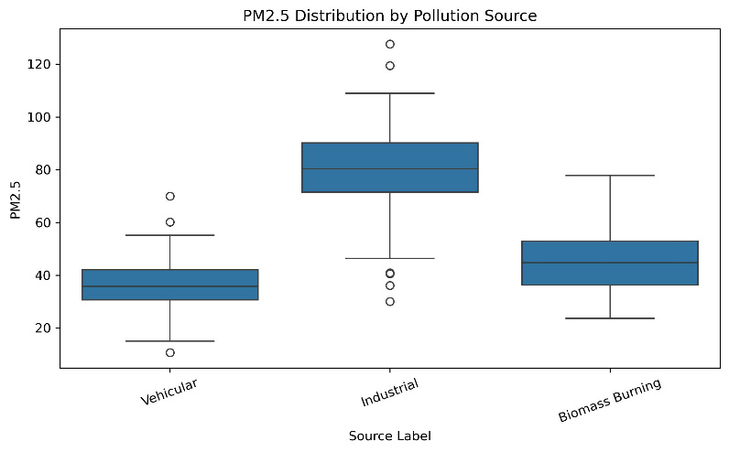
Fig. 2. [Boxplot of ${\text{PM}}_{2.5}$ across Location Types Of AirQuality]
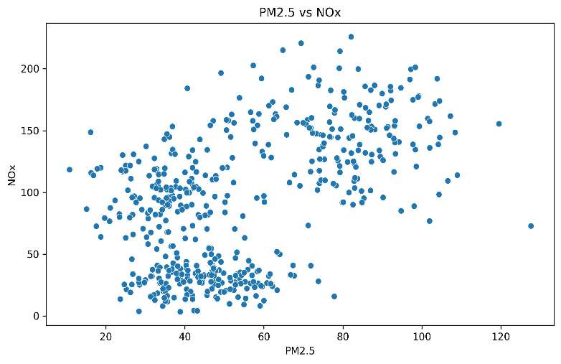
Fig. 3. [Scatter Plot (${\text{PM}}_{2.5}$ vs. ${\text{NO}}_{x}) Of AirQuality$]

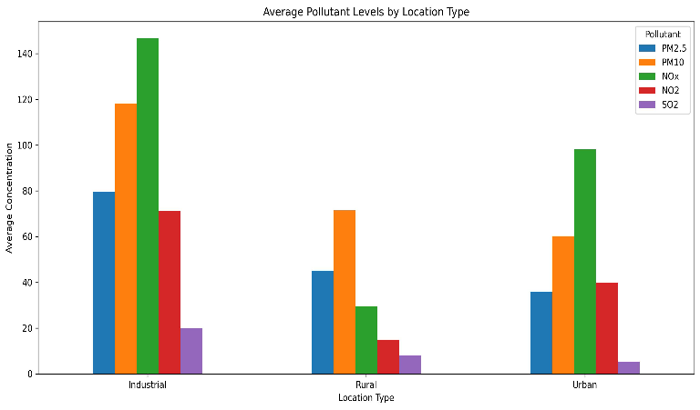
Fig. 4. [Grouped Bar Chart of Pollutants by Location]
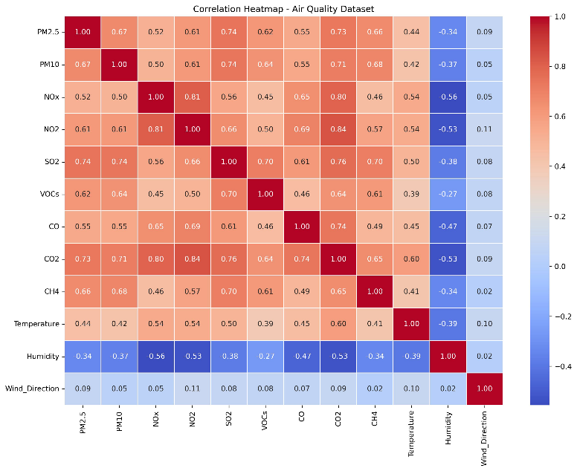
Fig. 5. [Correlation Heatmap Of AirQuality]
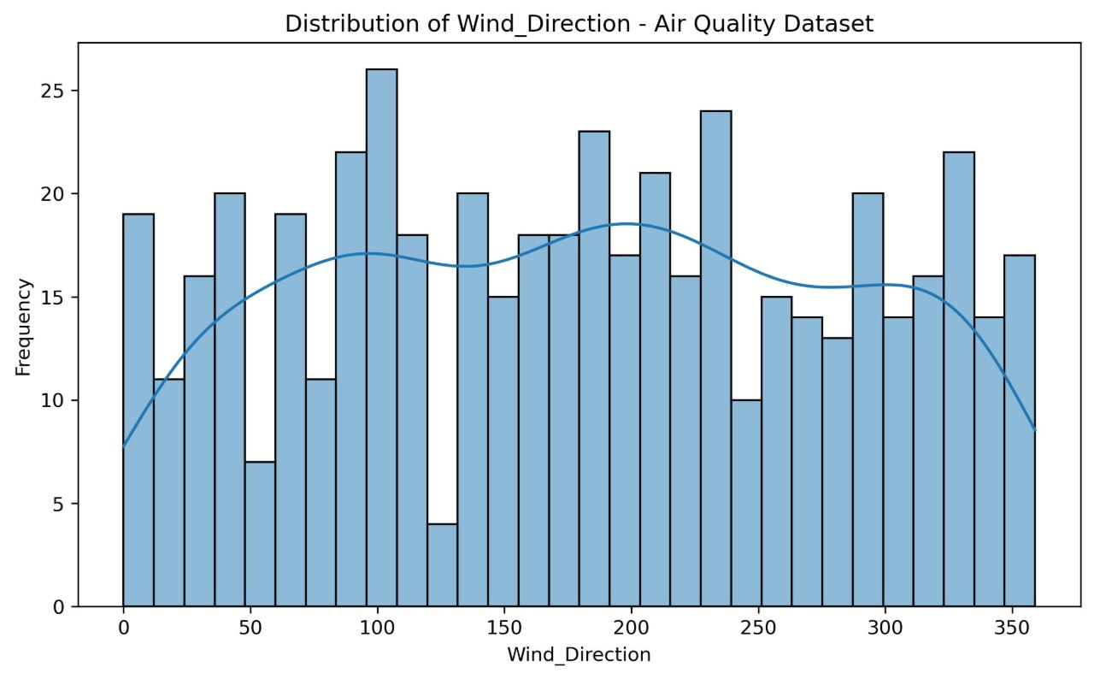
Fig.6. [Histogram with KDE for Wind Direction]

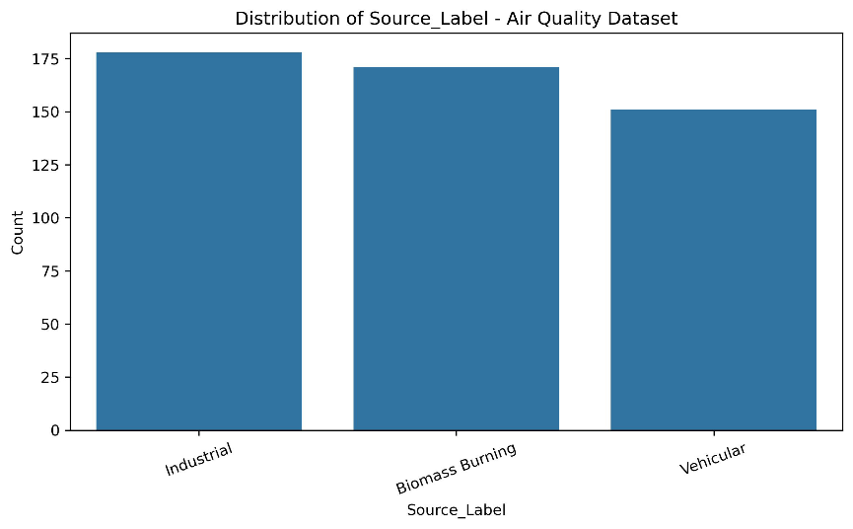
Fig.7. [Bar Chart of Emission Source Labels]
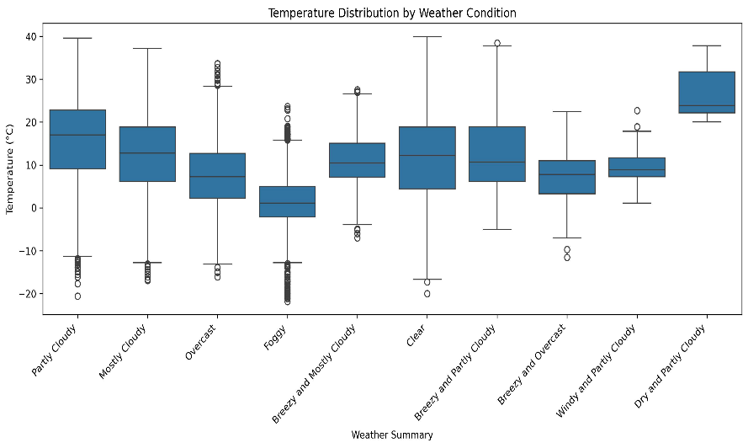
Fig 8. [Temperature Boxplot across Weather Conditions]

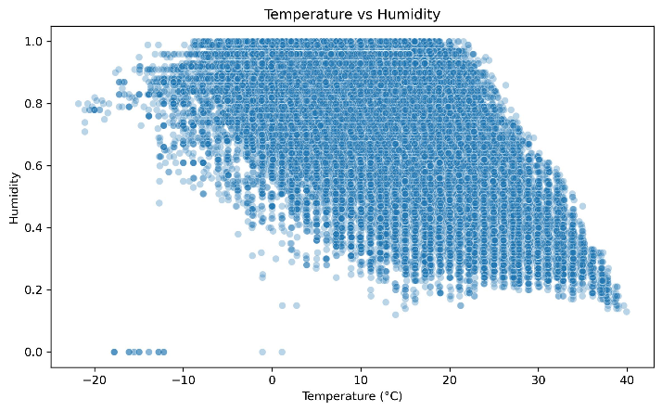
Fig 9. [Temperature vs. Humidity Scatter Plot]
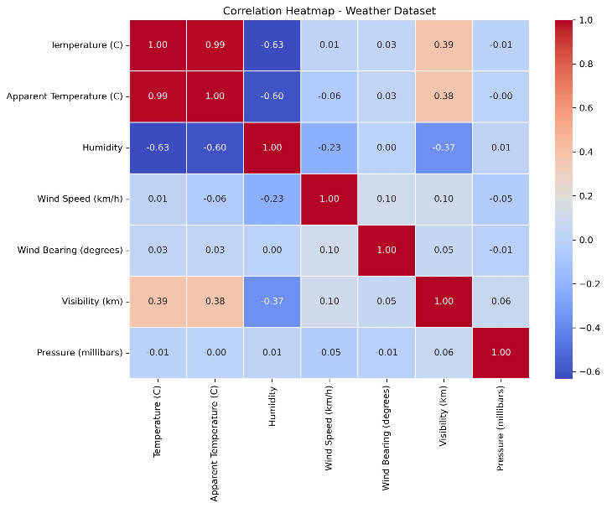
Fig 10. [Correlation Heatmap Of Weather]
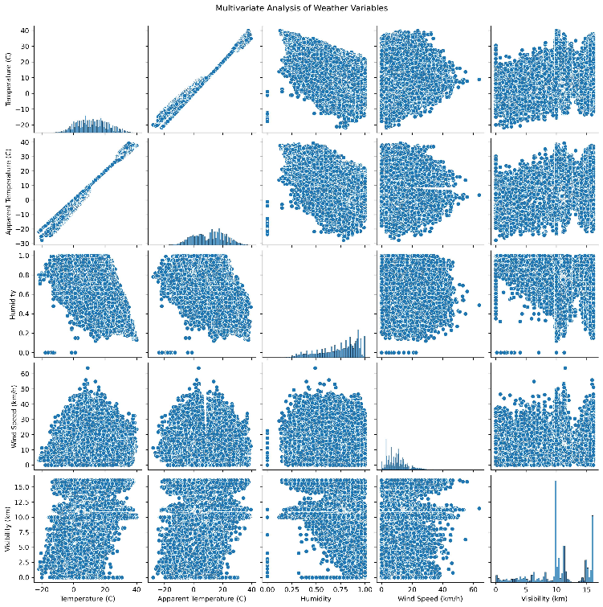
Fig 11. [Pairwise Scatter Matrix (Pairplot)]
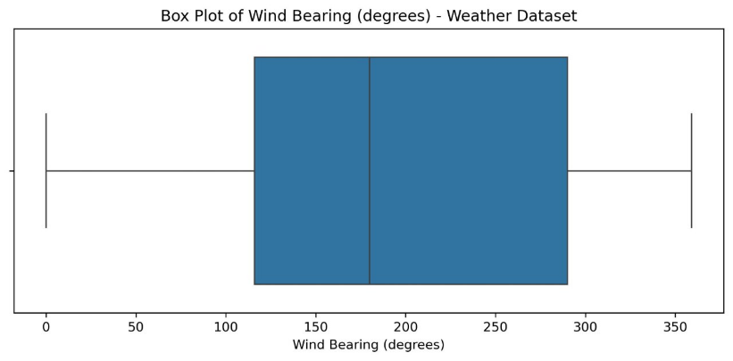
Fig 12. [Boxplot of Wind Bearing]
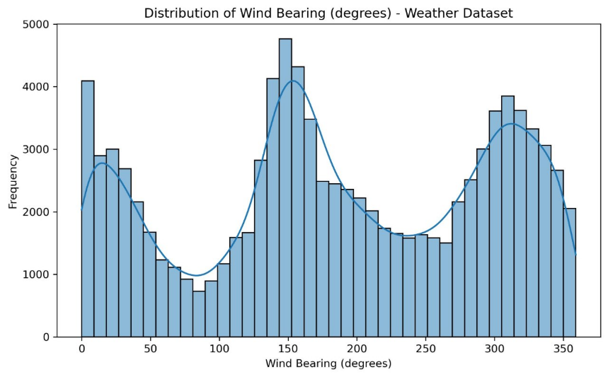
Fig 13. [Histogram with KDE of Wind Bearing]
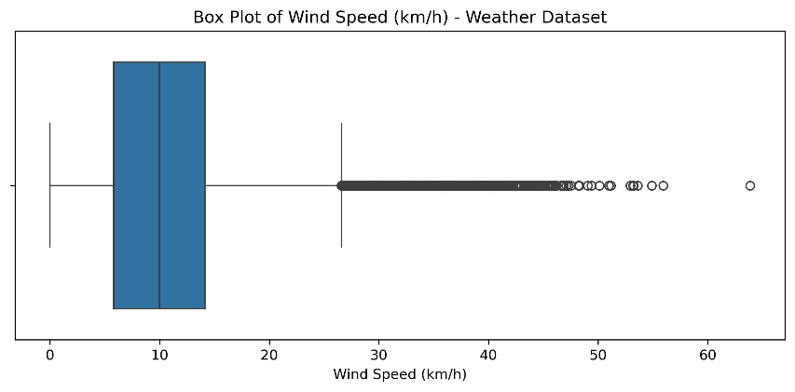
Fig 14. [Boxplot of Wind Speed]
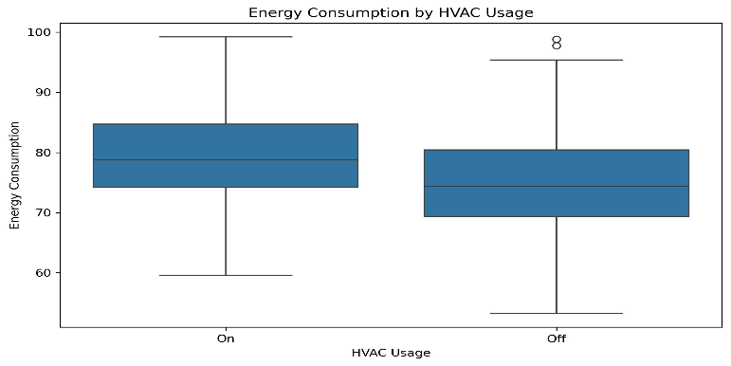
Fig 15. [Boxplot of Energy Consumption by HVAC Usage]
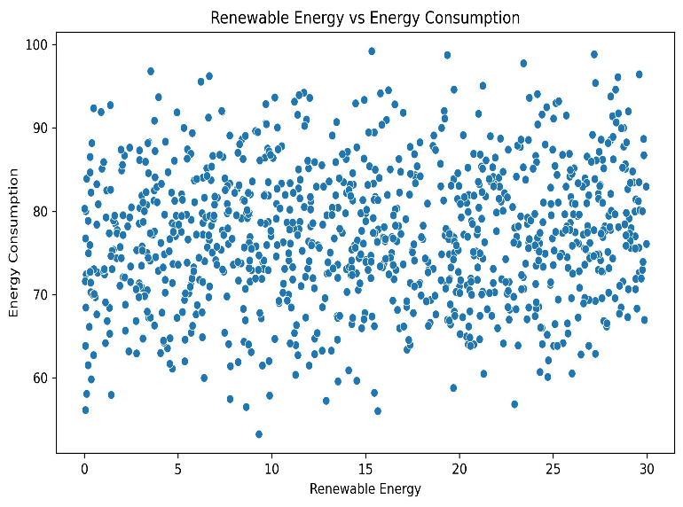
Fig 16. [Scatter Plot of Renewable Energy vs. Energy Consumption]
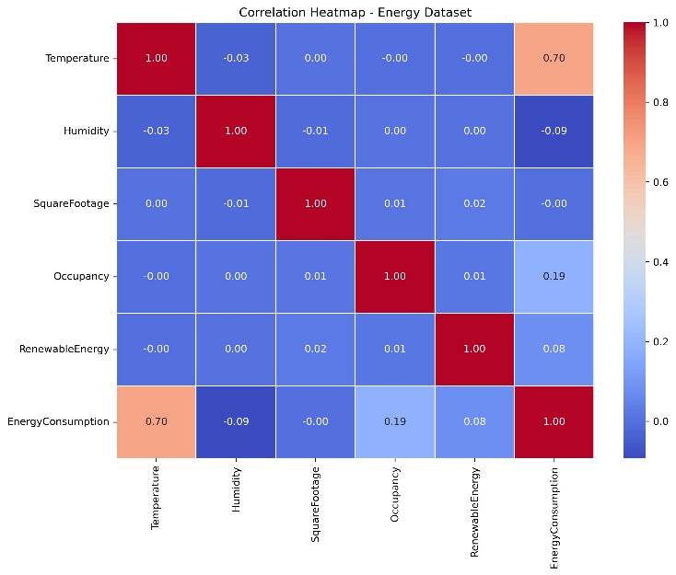
Fig 17. [Correlation Heatmap]
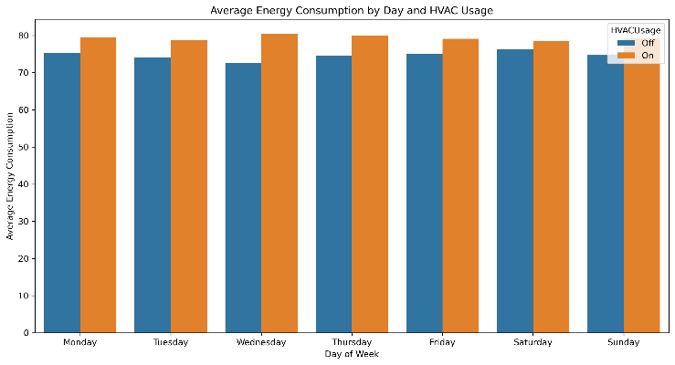
Fig 18. [Grouped Bar Chart of Average Energy Consumption by Day and HVAC Usage]

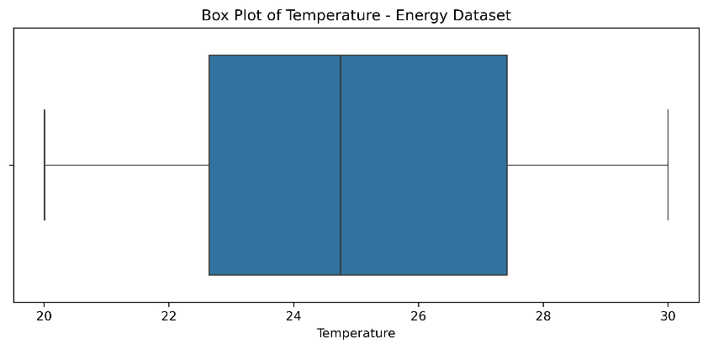
Fig 19. [Boxplot of Temperature]

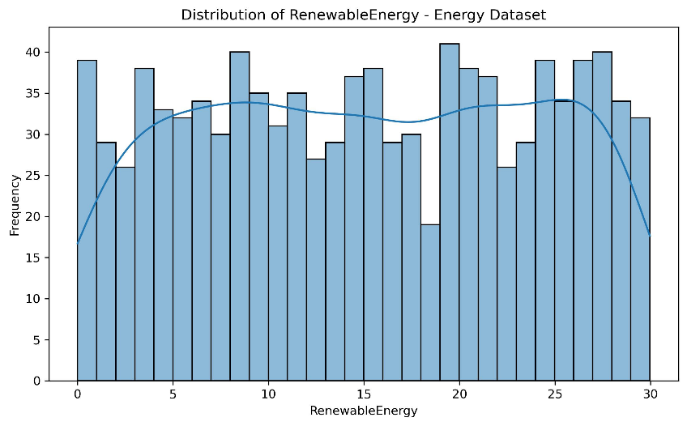
Fig 20. [Histogram with KDE of Renewable Energy]

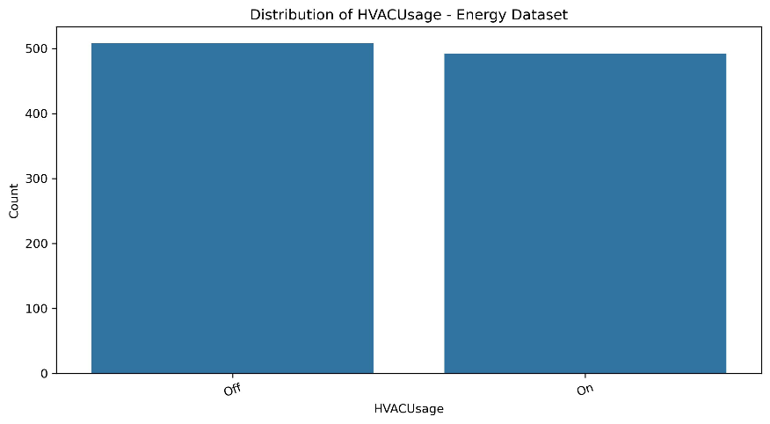
Fig 21. [Fig 20. [Histogram with KDE of Renewable Energy]

3.5 Proposed Model(s) and Baselines
- Linear Regression - Simple baseline model that uses linear relationships between the variables to predict the target. [14]
- Decision Tree - Model to capture non-linear relationships. Can be easily interpreted. [13]
- Random Forest - Uses multiple decision trees to improve the accuracy of predictions and reduce overfitting. [11]
- SHAP - Tool to explain how the model makes predictions and identify what features contribute to the predictions. [15]

3.6 Algorithmic / Mathematical Formulation
. Linear Regression Model
$$\overset{ˆ}{y}=β_{0}+\sum_{i=1}^{p}{β_{i}}x_{i}$$
- $\overset{ˆ}{y}$: Predicted output value
- $β_{0}$: Y-intercept
- $β_{i}$: Weight / coefficient assigned to feature $x_{i}$
- $x_{i}$: Value of the $i$-th feature
- $p$: Total number of features

2. Evaluation Metrics
1. Mean Absolute Error (MAE)
$$\text{MAE}=\frac{1}{n}\sum_{i=1}^{n}{|}y_{i}-{\overset{ˆ}{y}}_{i}|$$
- $y_{i}$: Actual value
- ${\overset{ˆ}{y}}_{i}$: Predicted value
- $n$: Number of test observations

2. Mean Squared Error (MSE)
MSE measures the average squared difference between actual and predicted values. Squaring the errors gives greater weight to larger prediction errors. Lower MSE indicates better performance.
$$\text{MSE}=\frac{1}{n}\sum_{i=1}^{n}{{\left(y_{i}-{\overset{ˆ}{y}}_{i}\right)}^{2}}$$
3. Root Mean Squared Error (RMSE)
RMSE is the square root of MSE and represents the prediction error in the same units as the target variable. Lower RMSE indicates better predictive performance.
$$\text{RMSE}=\sqrt{\frac{1}{n}\sum_{i=1}^{n}{{\left(y_{i}-{\overset{ˆ}{y}}_{i}\right)}^{2}}}$$
4. Coefficient of Determination ($R^{2}$ Score)
$R^{2}$ measures the proportion of variation in the target variable explained by the model. A higher $R^{2}$ indicates better explanatory performance.
$$R^{2}=1-\frac{\sum_{i=1}^{n}{{\left(y_{i}-{\overset{ˆ}{y}}_{i}\right)}^{2}}}{\sum_{i=1}^{n}{{\left(y_{i}-\overline{y}\right)}^{2}}}$$
- $\overline{y}$: Mean of the actual target values
5. Median Absolute Error (Median AE)
Median Absolute Error is the median of the absolute differences between actual and predicted values. It is less influenced by extreme errors than mean-based error measures. Lower values indicate better predictive performance.
$$\text{Median AE}=\operatorname{median}\left(|y_{i}-{\overset{ˆ}{y}}_{i}|\right)$$
6. Explained Variance Score (EVS)
The Explained Variance Score measures the proportion of the variance in the target variable that is captured by the model predictions. A value closer to 1 indicates better performance.
$$\text{EVS}=1-\frac{\operatorname{Var}\left(y-\overset{ˆ}{y}\right)}{\operatorname{Var}\left(y\right)}$$
- $Var$: Variance
7. Maximum Error (Max Error)
Maximum Error represents the largest absolute difference between an actual value and its corresponding prediction. Lower values indicate that the model has smaller worst-case prediction errors.
$$\text{MaxError}=\max_{i}{|}y_{i}-{\overset{ˆ}{y}}_{i}|$$
8. Normalized Root Mean Squared Error (NRMSE)
NRMSE normalizes RMSE relative to the range of the observed target values, allowing error magnitude to be compared more consistently across datasets with different scales. In this study, NRMSE was expressed as a percentage.
$$\text{NRMSE}\left(\%\right)=\frac{\text{RMSE}}{y_{max}-y_{min}}×100$$
- $y_{max},y_{min}$: Maximum and minimum actual target values, respectively
9. Adjusted $R^{2}$ Score
Adjusted $R^{2}$ modifies the $R^{2}$ score by considering the number of predictors and observations. It penalizes the addition of predictors that do not provide sufficient explanatory improvement.
$$\text{Adjusted }R^{2}=1-\left(1-R^{2}\right)\frac{n-1}{n-p-1}$$
- $p$: Number of predictors
10. Mean Absolute Percentage Error (MAPE)
MAPE measures the average absolute prediction error as a percentage of the actual value. Lower MAPE indicates better predictive performance. MAPE was reported where it was applicable and reliably computable for the evaluated datasets.
$$\text{MAPE}\left(\%\right)=\frac{100}{n}\sum_{i=1}^{n}{\left|\frac{y_{i}-{\overset{ˆ}{y}}_{i}}{y_{i}}\right|}$$
- Constraint: $y_{i}≠0$

4. EXPERIMENTAL SETUP
4.1 Hardware and Software
The system was built using Python. Libraries such as Pandas and NumPy were used to manipulate the data. Matplotlib and Seaborn were used for exploratory data analysis. Scikit-learn was used for data preprocessing, feature selection, baseline regression models, evaluation and Linear Regression parts of the proposed hybrid model. Catboost and Gradient Boosting were used as additional base models. SHAP was used for model explanation. Joblib was used to save and load models and preprocessing. Streamlit was used to create the interactive research and smart city decision support dashboard.
Jupyter Notebook/Anaconda was used to create the analysis and models. PyCharm was used to organise and create the final Streamlit dashboard. The data was sourced from Kaggle. The system can be run on a standard PC with the capability to run Python analysis, machine learning models, SHAP analysis and Streamlit dashboard.
4.2 Dataset Split / Design
Each dataset was split into 80% training and 20% testing with a random state of 42. The training data was used to create the features and models. The testing data was used to evaluate the models.
Three baseline regression models were created for each domain. These were Linear Regression, Decision Tree and Random Forest. The models were evaluated using the training and testing data. The proposed hybrid model was created using Linear Regression, Catboost and Gradient Boosting. An out of fold (OOF) method was used to create predictions using the base models with 5 folds. This was then passed to a Linear Regression meta learner to create the final prediction.
The models were evaluated using Mean Absolute Error (MAE), Mean Squared Error (MSE), Root Mean Squared Error (RMSE), R2, Median Absolute Error, Explained Variance, Max Error, Normalised RMSE (NRMSE), Adjusted R2 and Mean Absolute Percentage Error (MAPE). This was done for the three smart city domains.
4.3 Hyperparameter Configuration
The machine learning models were set up with the appropriate default and domain specific hyperparameters. The Linear Regression model wasn’t tuned much. Decision Tree and Random Forest were setup with the appropriate tree based hyperparameters. Random Forest had 100 estimators and a random state of 42.
The proposed hybrid model was created using Linear Regression, Catboost and Gradient Boosting. The base models were combined using an out of fold (OOF) method with 5 folds. These base model predictions were then passed to a Linear Regression meta learner. This was done to provide a consistent comparison between the three smart city domains.
All models and preprocessing were saved as re-usable models.
4.4 Validation Strategy
The models were validated using train/test. The models were trained and then evaluated on the test data. The models were compared using MAE, MSE, RMSE and R2 scores.
4.5 Evaluation Metrics
- Mean Absolute Error (MAE) - Measures the average error between actual and predicted values. The lower the value the better.
- Root Mean Squared Error (RMSE) - Measures the square root of the average error. Larger errors are given more weight. The lower the value the better.
- R2 Score - Measures how well the model explains the data. Higher values (maximum of 1) the better.
- Mean Squared Error (MSE) - Measures the average error. The lower the value the better.
- Median Absolute Error - Measures the median error between actual and predicted values. The lower the value the better.
- Explained Variance - Measures how much of the variation in the data is explained by the model. The higher the value the better.
- Max Error - Measures the highest error between actual and predicted values. The lower the value the better.
- Normalised Root Mean Squared Error (NRMSE) - Measures the RMSE as a percentage of the actual values. The lower the value the better.
- Adjusted R2 - Measures how much variance is explained by the model taking into account the number of predictors. The higher the value the better.
- Mean Absolute Percentage Error (MAPE) - Measures the average error as a percentage of the actual values. The lower the value the better.
4.6 Statistical Significance
No statistical significance test was carried out. The models were evaluated and compared using a variety of metrics. This included Mean Absolute Error (MAE), Root Mean Squared Error (RMSE) and Coefficient of determination (R2). Lower MAE and RMSE values indicate lower errors in predictions. A higher R2 score indicates better performance.
5. RESULTS
The proposed framework was implemented for the three smart city domains. The baseline models were compared with the proposed model. The baseline models were Linear Regression, Decision Tree and Random Forest. The proposed model used Linear Regression, Catboost and Gradient Boosting with Linear Regression as the meta learner. An out of fold (OOF) method was used with 5 folds.
The results were evaluated using a variety of metrics. These included Mean Absolute Error (MAE), Mean Squared Error (MSE), Root Mean Squared Error (RMSE), R2, Median Absolute Error, Explained Variance, Max Error, NRMSE, Adjusted R2 and MAPE. It was found that performance differed between the domains. The proposed model performed well but did not outperform all baseline models. This indicated that the effectiveness of the models depended on the domain.
SHAP analysis was performed on the proposed hybrid model to identify what features contributed to the predictions. Global SHAP analysis was performed to identify the importance of features. Instance level analysis was performed for the three domains. Cross domain and scenario analysis was performed to identify relationships between environmental and energy variables.
The results were then displayed in a interactive dashboard using Streamlit.
  - Overall Performance
The proposed and baseline models performed differently on the three selected smart city datasets. The models were compared using MAE, MSE, RMSE, R2 and other metrics. This can be seen in Table 2 and Figure 3. The lower the MAE, MSE and RMSE values the lower the error in predictions. The higher the R2 and Explained Variance the better the model. It was found that the models performed differently depending on the domain. SHAP analysis was performed to identify what variables contributed to the predictions for the proposed model.
5.2 Model / Method Comparison

Table 2 shows the performance of the four models used in this study. The models were compared using MAE, MSE, RMSE and R2. The lower the MAE, MSE and RMSE the better the model performed. The higher the R2 the better the model performed. This provided an indication of how effective the proposed model was compared to the baselines.
Method | MAE | MSE | RMSE | R² | Median_AE | Explained_Variance | Max_Error | NRMSE_percent
Linear Regression | 0 | 0 | 0 | 1 | 0 | 1 | 0 | 0
Random Forest | 0.0845 | 0.0124 | 0.1114 | 0.983 | 0.0599 | 0.9831 | 0.37 | 4.2888
Decision Tree | 0.1381 | 0.037 | 0.1931 | 0.949 | 0.1007 | 0.9493 | 0.8227 | 7.4294
LinCatGB | 0 | 0 | 0 | 1 | 0 | 1 | 0 | 0

Table 2. [Evaluation Metrices of AirQuality Dataset]

Method | MAE | MSE | RMSE | R² | Median_AE | Explained_Variance | Max_Error | NRMSE_percent
Linear Regression | 3.2656 | 17.209 | 4.1484 | 0.8123 | 2.7206 | 0.8123 | 33.4449 | 7.0444
Decision Tree | 1.8121 | 7.559 | 2.7494 | 0.9176 | 1.0889 | 0.9176 | 21.2333 | 4.6687
Random Forest | 1.4283 | 3.7843 | 1.9453 | 0.9587 | 1.061 | 0.9587 | 14.2012 | 3.3034
LinCatGB | 1.9146 | 5.8729 | 2.4234 | 0.936 | 1.6164 | 0.936 | 17.6718 | 4.1152

Table 3. [Evaluation Metrices of Weather Dataset]

Method | MAE | MSE | RMSE | R² | Median_AE | Explained_Variance | Max_Error | NRMSE_percent
Linear Regression | 4.091 | 26.6669 | 5.164] | 0.5929 | 3.4197 | 0.593 | 17.9852 | 12.699
Decision Tree | 5.5513 | 48.6729 | 6.9766 | 0.2569 | 4.3107 | 0.2572 | 21.4642 | 17.1564
Random Forest | 4.3428 | 29.3336 | 5.4161 | 0.5522 | 3.8628 | 0.5522 | 18.8513 | 13.3188
LinCatGB | 4.1285 | 27.0009 | 5.1962 | 0.5878 | 3.6038 | 0.5878 | 17.9037 | 12.7782

Table 4. [Evaluation Metrices of Energy Dataset]
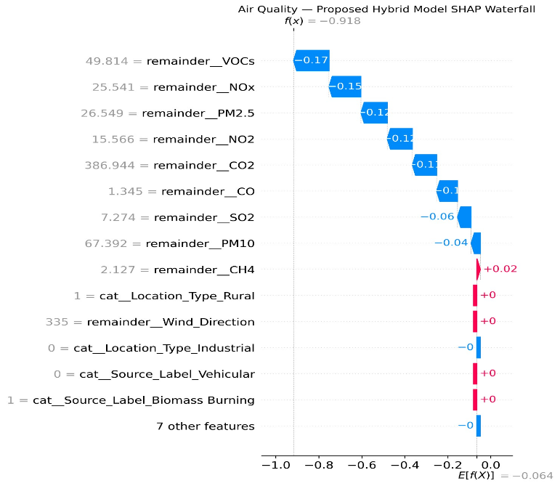
Fig. 22. [ SHAP Waterfall Plot for an Air Quality Prediction]
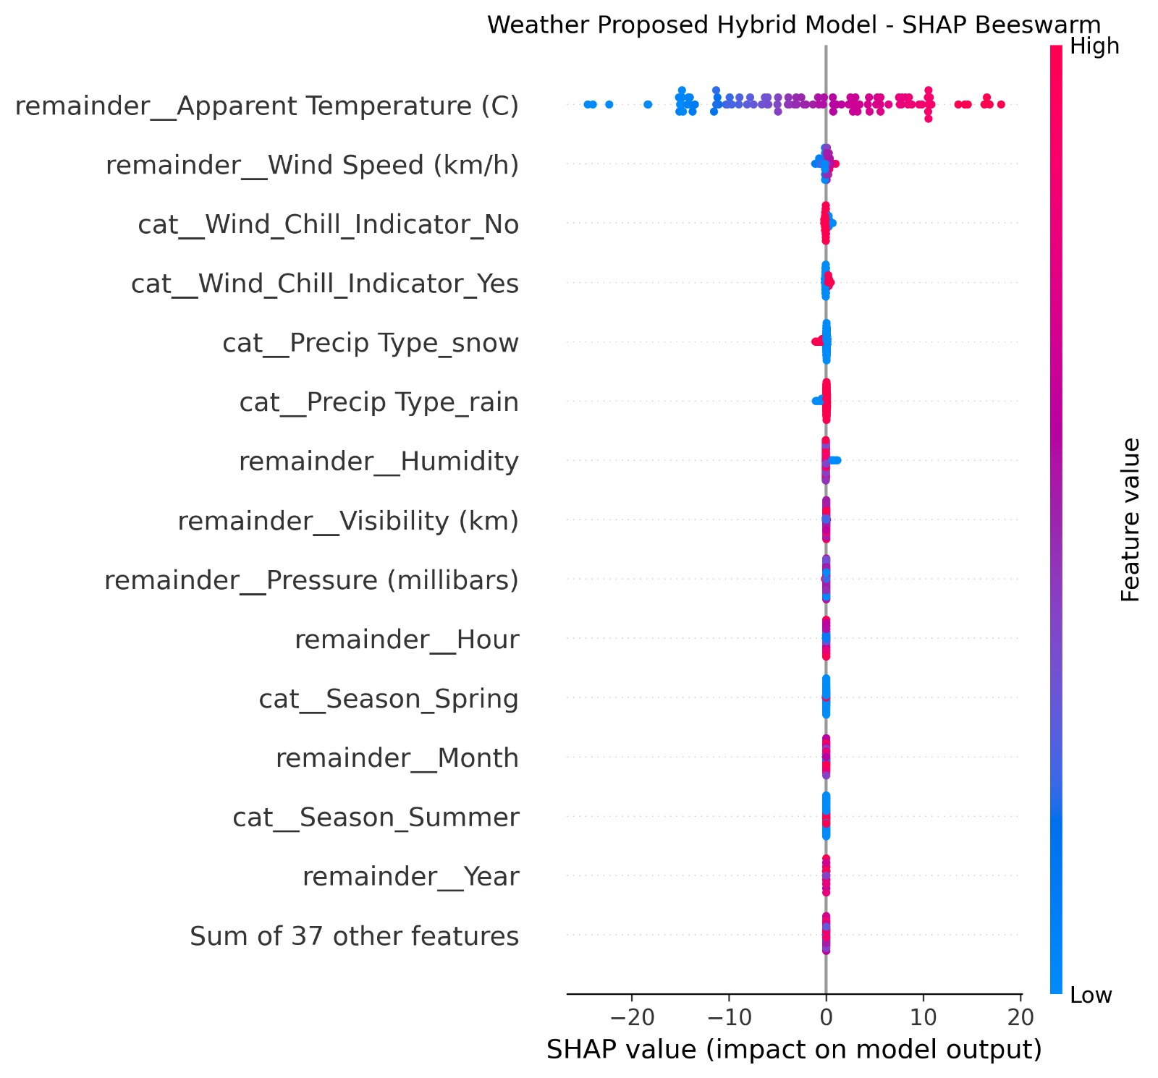
Fig. 23. [SHAP Beeswarm Plot for Weather Prediction.]
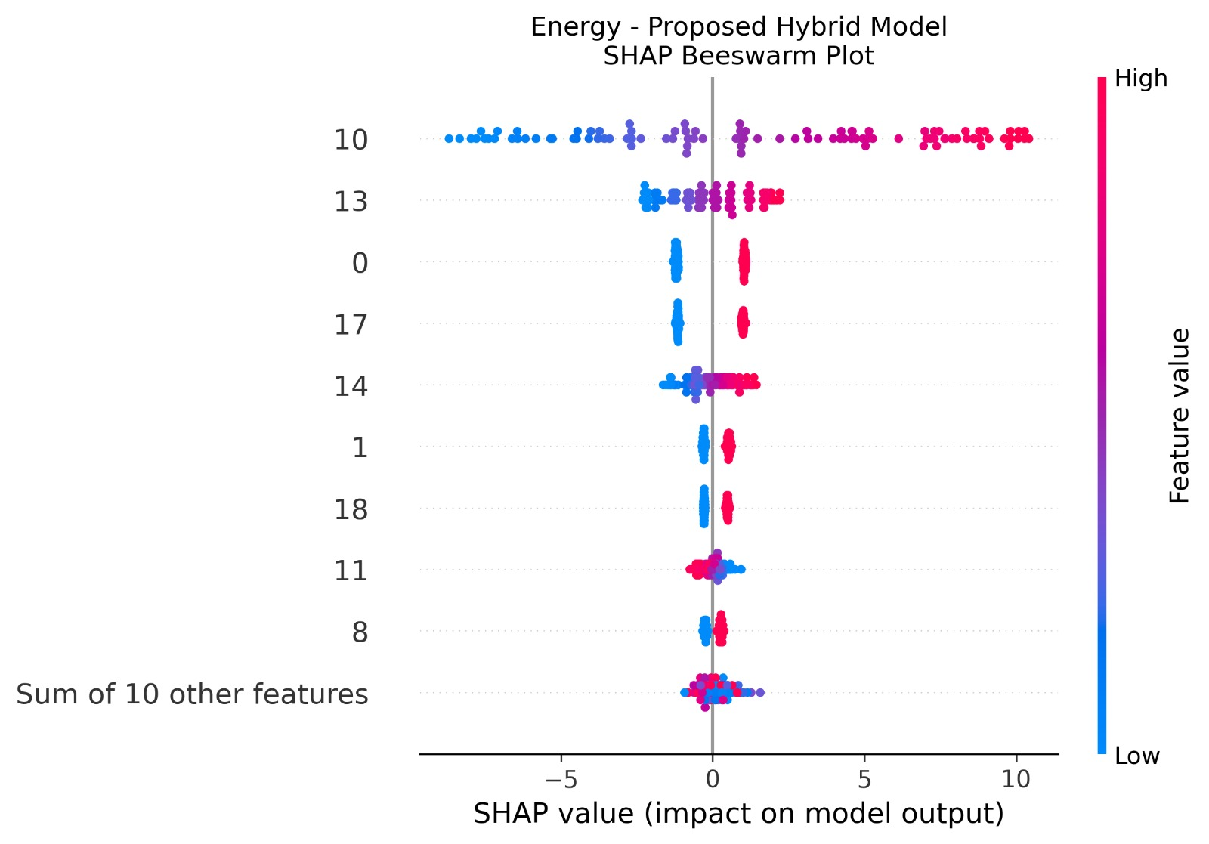
Fig. 24. [SHAP Beeswarm Plot for Energy Consumption Prediction.]
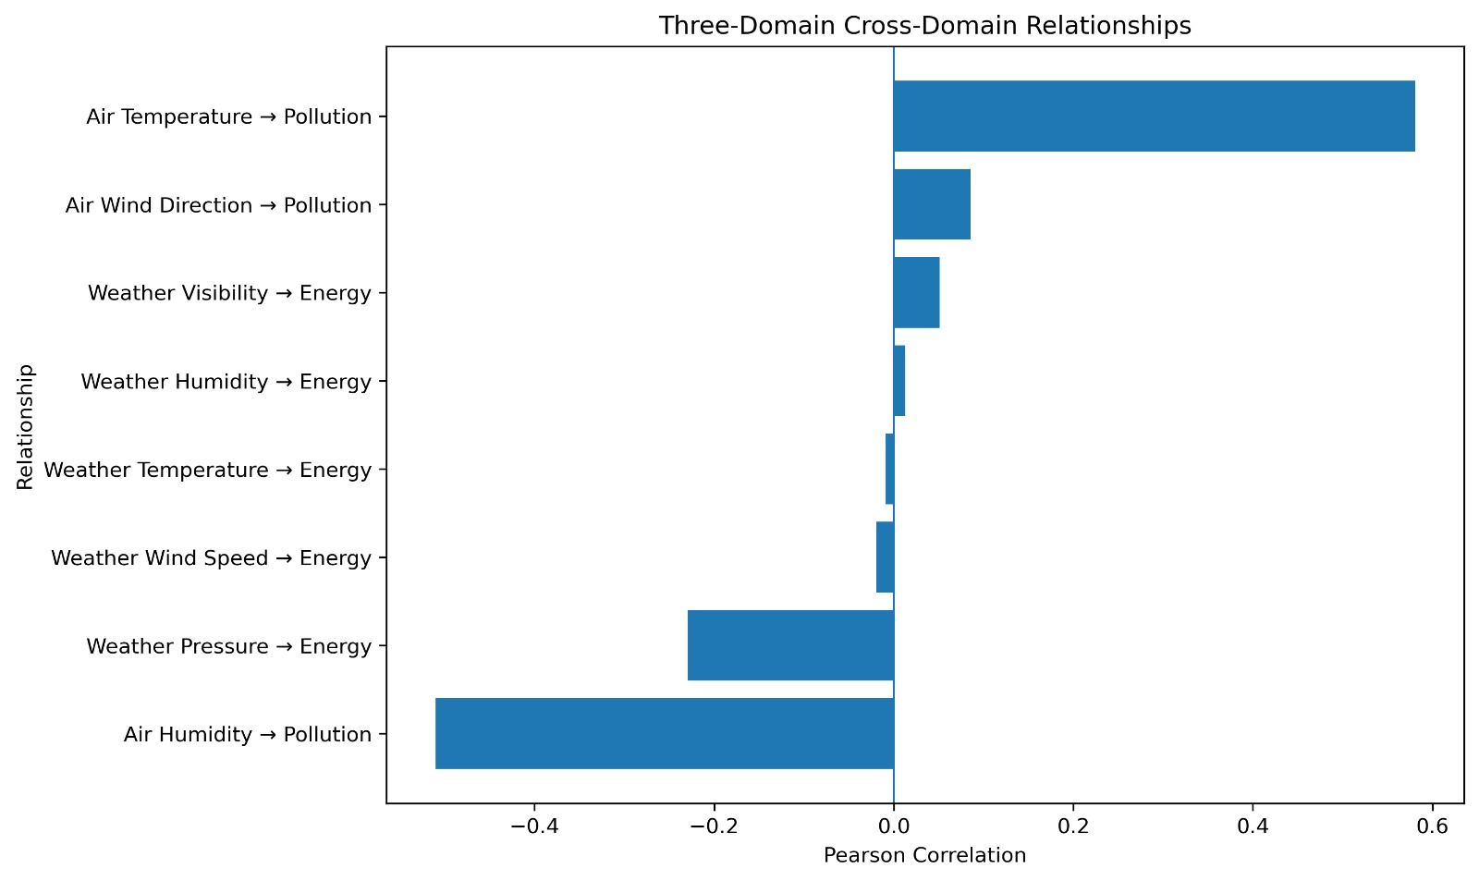
Fig. 25. [Cross-Domain Relationships Among Air Quality, Weather, and Energy Variables.]
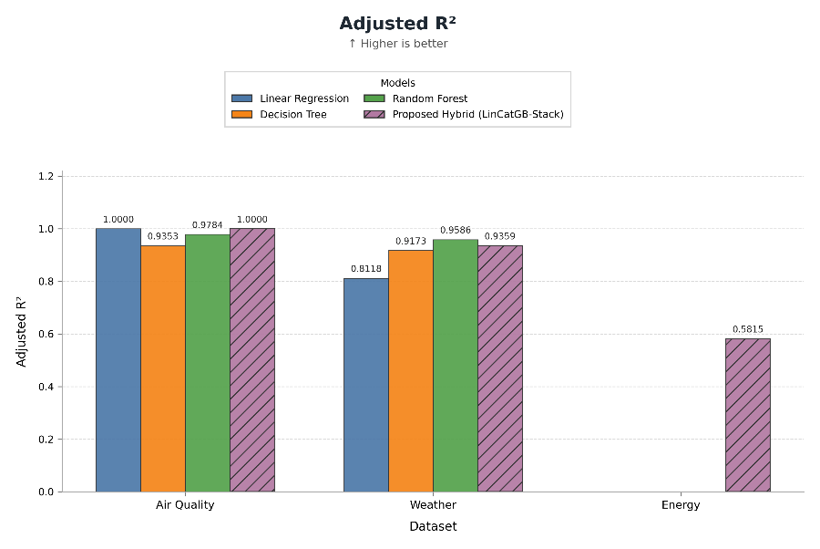
Fig. 26. [Comparison of Adjusted $R^{2}$ scores across different machine learning models and datasets.]

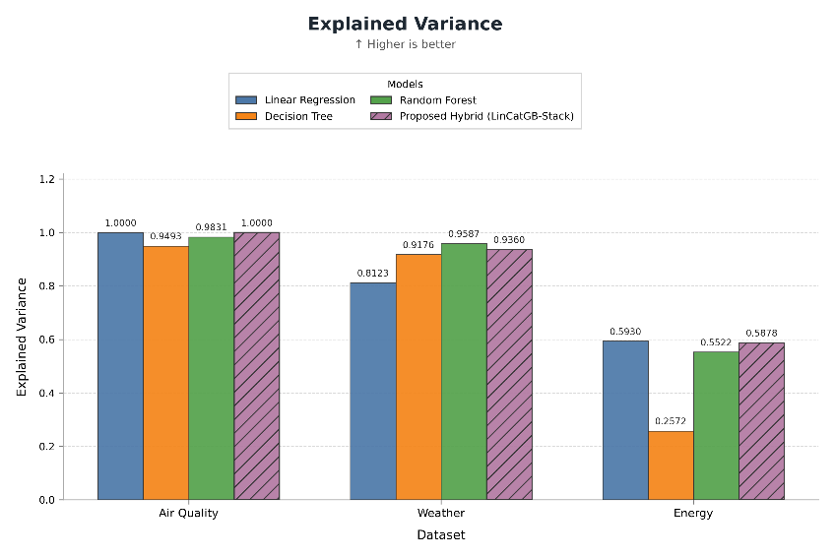
Fig. 27. [Comparison of Adjusted $R^{2}$ scores across different machine learning models and datasets.]
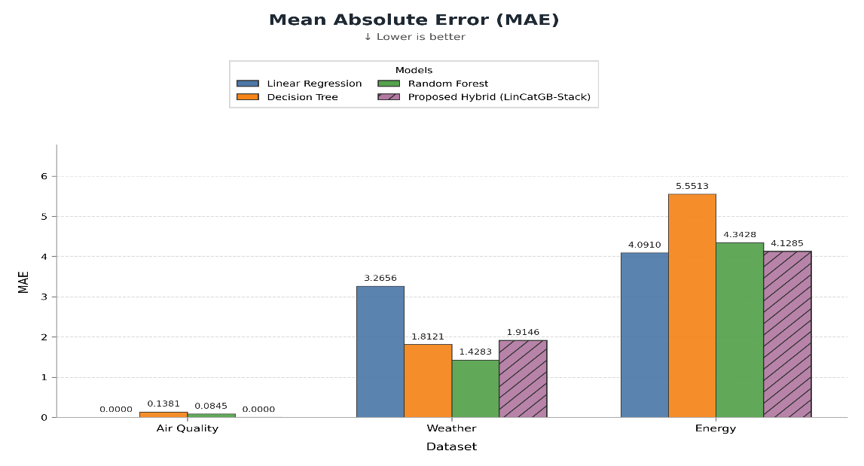
Fig. 28. [Mean Absolute Error (MAE) performance evaluation across datasets.]
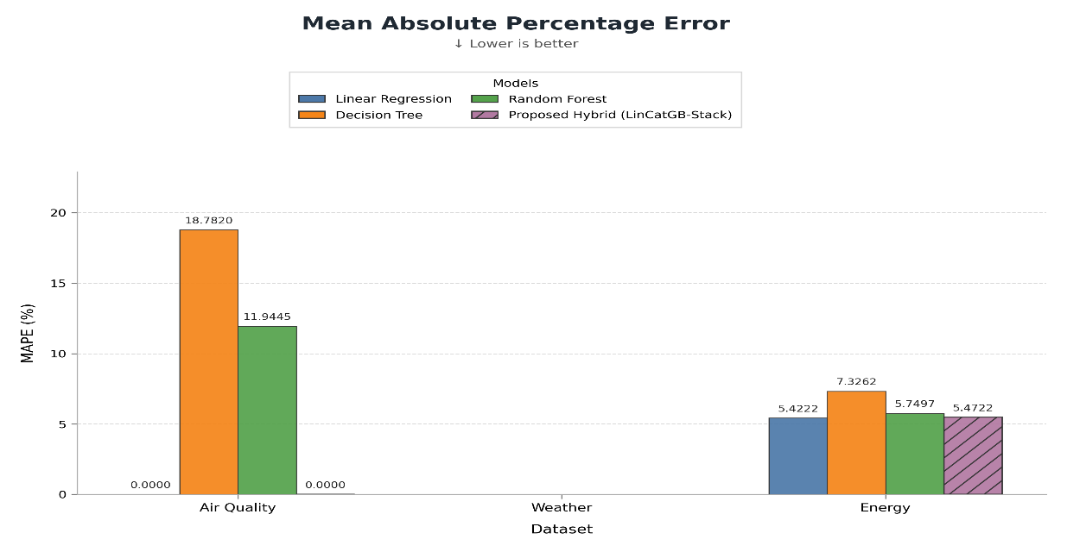
Fig. 29. [Mean Absolute Percentage Error (MAPE) evaluation across models and domains.]
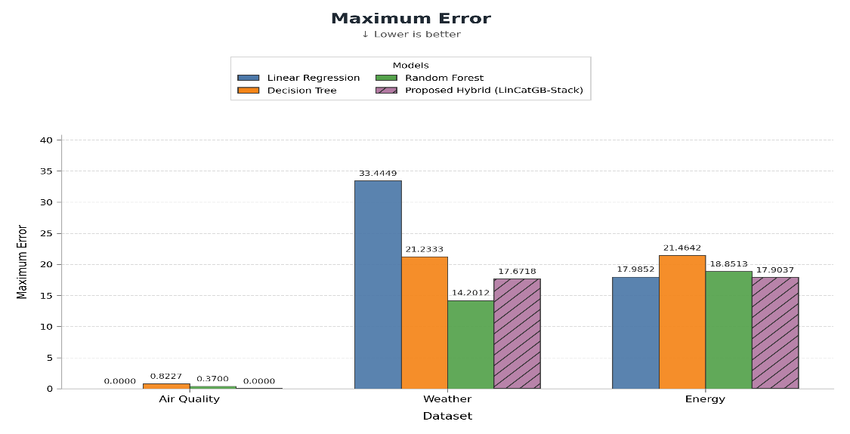
Fig. 30. [Maximum Error comparison for baseline models and the proposed hybrid approach.]
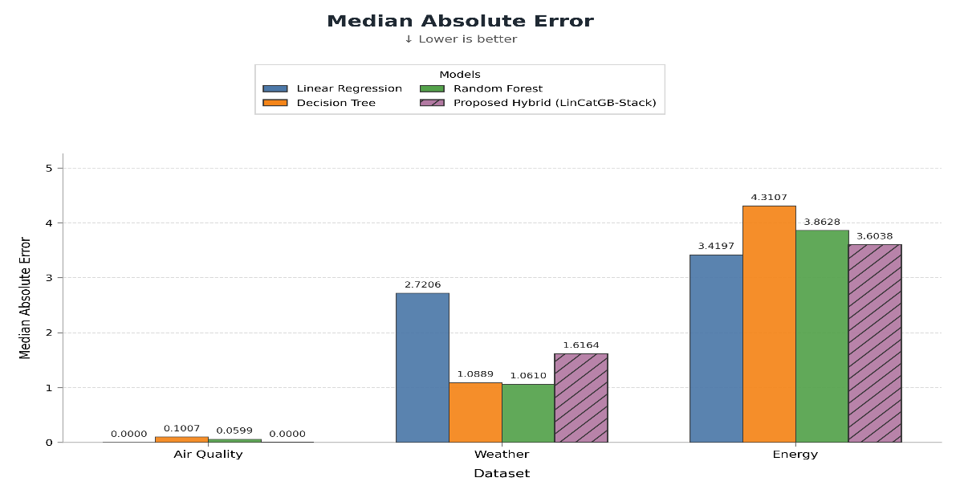
Fig. 31. [Median Absolute Error (MedAE) evaluation across baseline models and the proposed hybrid framework.]
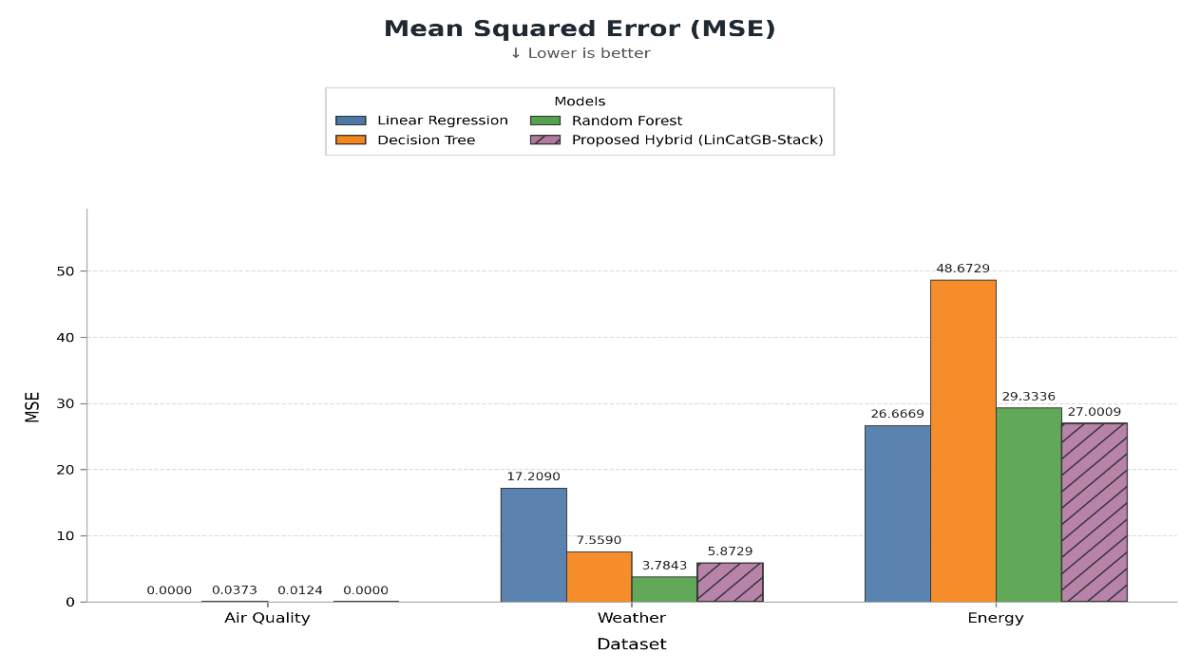
Fig. 32. [Mean Squared Error (MSE) performance comparison across datasets.]
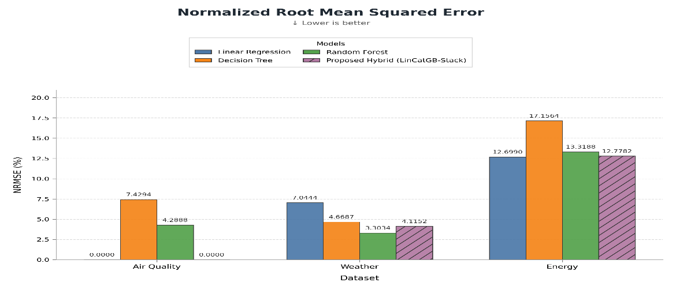
Fig. 33. [Normalized Root Mean Squared Error (NRMSE) performance across models and domains.]
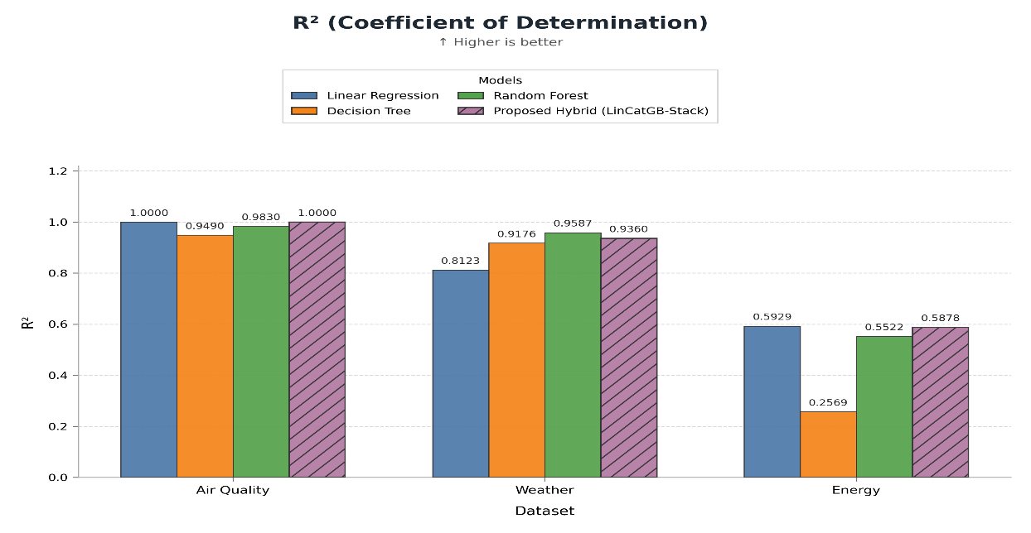
Fig. 34. [Coefficient of Determination ($R^{2}$) score comparison across baseline models and the proposed approach.]
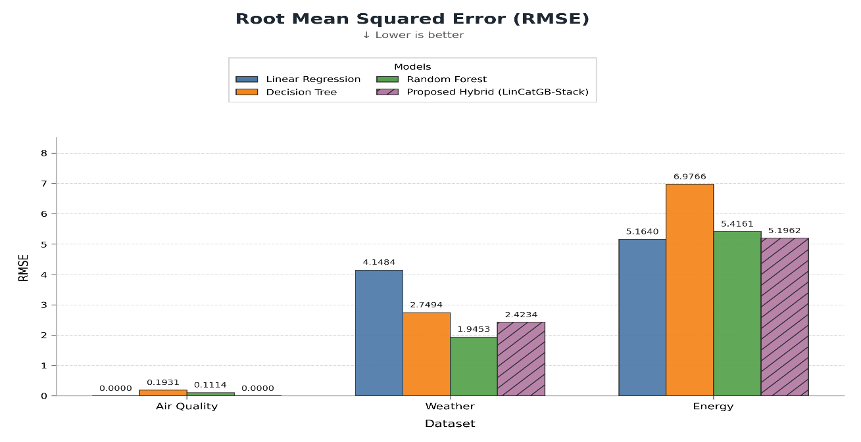
Fig. 35. [Root Mean Squared Error (RMSE) evaluation across models and datasets.]

  - [ Additional Result Sub-section, e.g., Error/Confusion Analysis]
The error of the models was evaluated using MAE, MSE, RMSE. The lower the values the better the model performed with less error. It was found that the models performed differently depending on the domain. R2 was used to measure how well each model explained the data. It was found that no model consistently performed best.
  - [ Additional Result Sub-section, e.g., Feature/Factor Importance]
SHAP analysis was performed on the proposed model to identify what features contributed to the predictions. Global SHAP analysis was performed to identify important features. Instance level analysis was performed to identify what factors contributed to the predictions. This provided an interpretable insight into what variables were contributing to air quality, weather and energy predictions.
6. DISCUSSION
6.1 Interpretation of Findings
The comparison showed that the models performed differently. Linear Regression, Decision Tree, Random Forest and the proposed model performed differently depending on the domain. It was found that the models effectiveness depended on the domain. The proposed model performed well but did not outperform all the baseline models. This indicated that stacking the models did not provide a universal performance benefit.
The SHAP analysis helped to interpret the proposed model by identifying what key environmental, weather and energy variables contributed to the predictions. Global and instance level analysis was performed.
Overall, the results showed that combining predictive analytics with explainable artificial intelligence can provide a valuable tool for sustainable smart cities. By combining prediction, explanation, cross domain and scenario analysis we can provide an more transparent analysis.
6.2 Comparison with Previous Studies
The proposed framework aligns with previous studies showing how machine learning and explainable AI can be used effectively for environmental and energy data. Several studies have looked at using machine learning, ensembles and explainable methods for air quality [1]-[3], [5], [6]. Several studies have shown how machine learning and explainable methods can be used for sustainable energy [4], [8], [9]. Machine learning has also been used for urban environmental predictions [7]. Recent studies have highlighted how important advanced learning methods and explainability are for air quality predictions [10]. Unlike these studies, this framework combines air quality, historical weather and energy data to provide a comprehensive smart city analysis. Multiple machine learning models were compared systematically. The proposed Out of Fold Linear-Catboost-Gradient Boosting Stacking Ensemble (LinCatGB-Stack) was included along with SHAP explainability, cross domain analysis, and interactive visualizations to support interpretable and practical smart-city decision-making.
6.3 Theoretical Implications
This study shows how heterogenous data can be combined with machine learning and explainable AI to help provide a wider insight into sustainable smart city applications. It is shown that simply having a high performance on predictions isn’t enough to understand complex data types such as environmental and energy data. It is also important to know which variables have led to the predictions.
It is also shown that models can vary between different domains and therefore when choosing a model to use it is important to know what type of data you are working with. It provides a wider view into how models perform when using comparative modelling, SHAP explanations and cross-domain analysis.
6.4 Practical Implications
The framework can be used to help urban planners, analysts and other decision makers in smart cities gain more insight into environmental and energy patterns. The framework provides the user with predictive models, interactive dashboards, SHAP explanations, cross-domain relationships and scenario analysis to gain a better understanding of complex machine learning results.
The interactive dashboard allows the user to view predictions, the variables that have caused these predictions, cross-domain relationships and recommendations. This can help with gaining an understanding of the data to make decisions. This framework should be used to support decisions.
6.5 Unexpected Findings
One of the unexpected results was that the hybrid model didn’t outperform the base models across all three domains. Whilst the hybrid model had comparable performance, the Random Forest model had a better performance for the Weather dataset. The Linear Regression model had a slightly better performance than the hybrid for the Energy dataset. This shows that combining multiple models doesn’t necessarily mean the performance will be better.
The feature importance also varied across different domains. SHAP analysis showed different variables had contributed to predictions within the three domains. This highlights how models can vary between different domains and how important it is to understand how they work.
The Air Quality results provided almost perfect performance from the Linear Regression and hybrid models. This was an unusually high performance so should be taken with care depending on the data characteristics and size.
LIMITATIONS
Limited Data – Only specific datasets have been used to analyse the air quality, weather and energy consumption data. This may not cover all urban environments, infrastructure and environments.
Varied Data – The size and characteristics of the data vary greatly. The Air Quality dataset has a limited amount of records.
Data Quality – The analysis of the data relies on the quality of the data. Data cleaning was carried out to handle any issues such as missing values or duplicate records. However, there may still be issues with the data depending on how it has been collected.
Model Performance – The performance of the models can vary between datasets depending on the available features, data characteristics and model. It cannot be assumed that the hybrid model will outperform in all smart city domains.
Cross-Domain – Cross-domain analysis was carried out with compatible variables and time-stamps. However, the Air Quality dataset didn’t provide an appropriate time stamp so this shouldn’t be seen as fully time aligned.
Generalisation – The results are based on the specific datasets so may not be able to generalise well across different cities, regions or environments.
Interpretation – SHAP analysis provides insights into how features have contributed to predictions but does not show causality. The scenarios and recommendations provide analysis to help make decisions.
8. CONCLUSION AND FUTURE WORK
This study has developed and analysed an explainable data analysis framework for sustainable smart city applications. This was done by analysing heterogenous data from air quality, weather and energy consumption. The framework includes data cleaning, exploratory analysis, feature engineering, feature selection, comparative modelling, hybrid modelling, SHAP explanations and scenario analysis.
Three models were analysed including Linear Regression, Decision Tree and Random Forest. These were compared to a hybrid model consisting of Linear Regression, CatBoost and Gradient Boosting. This was combined using 5-fold out of fold stacking with a Linear Regression meta learner. The results showed that performance varied between the three domains. The hybrid model had comparable performance but didn’t outperform the base models. This shows that the performance of models depend on the characteristics of the data.
The SHAP analysis provided insights into how the hybrid model works globally and locally. This helped to identify which features were contributing to predictions in each domain. The cross-domain analysis and scenario analysis provided insights into how the environmental and energy variables relate. This wasn’t claiming any causality. All of this was put together to create an interactive dashboard using Streamlit.
Overall this study shows how combining predictive analytics, explainable AI and cross-domain analysis can provide a transparent and wider framework for sustainable smart city analysis. The framework can be used to support decision making.
Future Work
The framework can be developed further by incorporating larger and more diverse data sets. Real world sensor data and IoT data can be used to provide a better time alignment. Future studies could look into using more advanced ensemble and hybrid models. Future work could also look into systematic hyperparameter tuning and alternative explanation methods to further analyse how the model performs.
The cross-domain analysis can be further developed to include more urban domains such as traffic, water management, waste management and renewable energy. Future research could also be carried out to investigate causality and time forecasting if suitable data is available. The dashboard can be developed further with up to date data sources and more advanced decision making whilst keeping transparency and interpretability.
DECLARATIONS
Funding
This study has not received any external funding.
Conflict of Interest
There are no conflicts of interest.
Ethics Statement
The study uses publicly available data so there are no human participants, personal data was not collected and there was no experiment requiring ethics approval.
Data Availability
The data used from this study is publicly available via Kaggle. The study used the Air Quality Dataset, Synthetic Weather Dataset and Energy Consumption Prediction Dataset.
Author Contributions
• [Sharmila Pathi] - Conceptualisation, Methodology, Data Cleaning, and Model Development.
• [Vishnu Priya Kodali] - Data analysis, Visualization, and Results Evaluation.
• [Ivaturi Vennela] - Explainable AI Analysis, Documentation, and Manuscript Writing.
• [Lakshman Angara] - Literature Review, Validation, and Manuscript Review.
Acknowledgements
We would like to thank our project guide and institution for their support.
REFERENCES
[1] E. Birinci, Ö. Ekmekcioğlu, H. Ozdemir and A. Deniz, "Interpretable Machine Learning Framework for Air Quality Prediction in Istanbul Using Shapley Additive Explanations (SHAP)," Stochastic Environmental Research and Risk Assessment, vol. 40, art. no. 37, 2026. https://doi.org/10.1007/s00477-026-03168-4.
[2] E. Mohapatra, M. Das and S. Rath, "Deep learning based AQI forecasting using CNN-LSTM with visual insights using SHAP-LIME and PDP," Discover Applied Sciences, vol. 7, art. no. 1326, 2025. https://doi.org/10.1007/s42452-025-07845-x.
[3] M.W. Jalali, B. Saidi, H. Farahmand, M.A. Rezvan Panah and E.N. Saruhan, "Scalable AI-enabled air quality forecast and classification for public health purposes," Discover Atmosphere, vol. 3, art. no. 25, 2025. https://doi.org/10.1007/s44292-025-00052-8.
[4] A. Hussien, A. Maksoud, A. Al-Dahhan, A. Abdeen and T. Baker, "A machine learning model for long term building energy consumption prediction," Discover Internet of Things, vol. 5, art. no. 18, 2025. https://doi.org/10.1007/s43926-025-00115-7.
[5] Y. Özüpak, F. Alpsalaz and E. Aslan, "Air quality prediction using machine learning models with comparative analysis and ensemble approach," Water, Air & Soil Pollution, vol. 236, art. no. 464, 2025. https://doi.org/10.1007/s11270-025-08122-8.
[6] E. Koçak, "Comprehensive Evaluation of Machine Learning Models for Real-World Air Quality Prediction and Health Risk Assessment by AirQ+," Earth Science Informatics, vol. 18, art. no. 447, 2025. https://doi.org/10.1007/s12145-025-01941-7.
[7] S. Tomar and K.S. Kulkarni, "Smart Cities, Hot Cities: Smart City Heat Prediction Using Machine Learning," Discover Sustainability, vol. 6, art. no. 1260, 2025. https://doi.org/10.1007/s43621-025-02059-y.
[8] E.I. Abd El-Latif and M. El-dosuky, "Explainable smart city energy consumption and speed prediction using deep learning," Neural Computing and Applications, vol. 37, pp. 6233-6249, 2025. https://doi.org/10.1007/s00521-024-10850-7.
[9] T.A. Abd'Azeez and L. Olatomiwa, "Energy consumption prediction system using machine learning model with API," Journal of Electrical Systems and Information Technology, vol. 12, art. no. 50, 2025. https://doi.org/10.1186/s43067-025-00242-9.
[10] A. Mishra and Y.K. Gupta, "State-of-the-Art and Emerging Trends in Deep Learning for Air Quality Forecasting and Health Impact Modelling: A Comprehensive Review," 2025 2nd Global AI Summit - International Conference on Artificial Intelligence and Emerging Technology (AI Summit), pp. 1301-1306, 2025. https://doi.org/10.1109/AISummit66170.2025.11410867.
[11] L. Breiman, "Random forests," Machine Learning, vol. 45, pp. 5-32, 2001. https://doi.org/10.1023/A:1010933404324.
[12] T. Chen and C. Guestrin, "XGBoost: A Scalable Tree Boosting System," in Proceedings of the 22nd ACM SIGKDD International Conference on Knowledge Discovery and Data Mining, pp. 785-794, 2016. https://doi.org/10.1145/2939672.2939785.
[13] L. Breiman, J.H. Friedman, R.A. Olshen and C.J. Stone, Classification and Regression Trees. Belmont, CA, USA: Wadsworth, 1984.
[14] C.M. Bishop, Pattern Recognition and Machine Learning. New York, NY, USA: Springer, 2006.
[15] S.M. Lundberg and S.-I. Lee, "A unified approach to interpreting model predictions," in Advances in Neural Information Processing Systems, vol. 30, pp. 4765-4774, 2017.
[16] T. Peng, J. Xiong, K. Sun, S. Qian, Z. Tao, M.S. Nazir and C. Zhang, "Research and Application of a Novel Selective Stacking Ensemble Model Based on Error Compensation and Parameter Optimization: For AQI Prediction," Environmental Research, vol. 247, art. no. 118176, 2024. https://doi.org/10.1016/j.envres.2024.118176.
[17] G. Ravindiran, K. Karthick, S. Rajamanickam, D. Datta, B. Das, G. Shyamala, G. Hayder and A. Maria, "Machine learning ensemble stacking approach for air quality prediction in Hyderabad city of India," iScience, vol. 28, no. 2, art. no. 111894, 2025. https://doi.org/10.1016/j.isci.2025.111894.
[18] C. Ragupathi, S. Dhanasekaran, N. Vijayalakshmi and A.O. Salau, "Electricity consumption prediction using innovative deep energy predictor model," Energy Reports, vol. 12, pp. 5320-5337, 2024. https://doi.org/10.1016/j.egyr.2024.11.018.
[19] N. Aouidi, F. Ben Naceur and C. Ben Salah, "Long-Term Energy Consumption Forecasting Using Hybrid LSTM-XGBoost Approach," in 2025 International Conference on Control, Decision and Information Technologies (CoDIT), pp. 2852-2857, 2025. https://doi.org/10.1109/CoDIT66093.2025.11321664.
[20] Y. Liu, B. Li and H. Liang, "Building Electricity Prediction Using BILSTM-RF-XGBOOST Hybrid Model with Improved Hyperparameters Based on Bayesian Algorithm," Electronics, vol. 14, no. 11, art. no. 2287, 2025. https://doi.org/10.3390/electronics14112287.
[21] M. Huo, W. Yan, G. Ren and Y. Li, "A novel hybrid model based on modal decomposition and error correction for building energy consumption prediction," Energy, vol. 294, art. no. 130811, 2024. https://doi.org/10.1016/j.energy.2024.130811.
[22] R.S. Rao, L.R. Kalabarige, B. Alankar and A.K. Sahu, "Multimodal imputation based stacked ensemble for prediction and classification of air quality index of Indian cities," Computers & Electrical Engineering, vol. 114, art. no. 109098, 2024. https://doi.org/10.1016/j.compeleceng.2024.109098.
[23] G. Sharma, S. Khurana, N. Saina, Shivansh and G. Gupta, "Comparative Analysis of Machine Learning Techniques in Air Quality Index (AQI) prediction in smart cities," International Journal of System Assurance Engineering and Management, vol. 15, no. 7, pp. 3060-3075, 2024. https://doi.org/10.1007/s13198-024-02315-w.
[24] W.M. Shaban, X. Dongxi, K.S. Daef and K. Elbaz, "Real-time early warning and prediction of air pollutants for sustainable development in smart cities," Atmospheric Pollution Research, vol. 15, no. 7, art. no. 102162, 2024. https://doi.org/10.1016/j.apr.2024.102162.
[25] A. Binbusayyis, M.A. Khan, M.M. Ahmed A. and W.R. Sam Emmanuel, "A Deep Learning Approach for Prediction of Air Quality Index in Smart City," Discover Sustainability, vol. 5, art. no. 89, 2024. https://doi.org/10.1007/s43621-024-00272-9.
[26] B.A. Salami, S.I. Abba, A.A. Adewumi, U.A. Dodo, G.K. Otukogbe and L.O. Oyedele, "Building energy loads prediction using bayesian based metaheuristic optimised-explainable tree-based model," Case Studies in Construction Materials, vol. 19, art. no. e02676, 2023. https://doi.org/10.1016/j.cscm.2023.e02676.
[27] R. Akter, M.G. Shirkoohi, J. Wang and W. Mérida, "An efficient hybrid deep neural network model for multi horizon power load forecasting in academic buildings," Energy and Buildings, vol. 329, art. no. 115217, 2025. https://doi.org/10.1016/j.enbuild.2024.115217.
[28] C. Zhou, Z. Wang, X. Wang, R. Guo, X. Xiang and Y. Wu, "Deciphering the nonlinear and synergistic role of building energy variables in shaping carbon emissions: LightGBM-SHAP framework in office buildings," Building and Environment, vol. 266, art. no. 112035, 2024. https://doi.org/10.1016/j.buildenv.2024.112035.
[29] A. Khalid, "Weather prediction using machine learning classifiers," Journal of Innovative Computing and Emerging Technologies, vol. 4, no. 2, 2024. https://doi.org/10.56536/jicet.v4i2.144.
[30] S.M. Malakouti, "Using SHapley Additive exPlanations to obtain efficient rain fall forecasts (SHAP)," Scientific Reports, vol. 15, art. no. 36499, 2025. https://doi.org/10.1038/s41598-025-22081-4.

